INTRODUCTION

This chapter gives an introduction to our project. The problems existing in the current scenario provided us with the necessary guidelines. We will be discussing about the nature of the problem and explain how we will deal with the problem existing in this first chapter.
Group Communication Systems are distributed messaging systems that enable efficient communication between a set of processes logically organized in groups and communicating via multicast in an asynchronous environment. More specifically they provide two services:
- Group membership
- Reliable and ordered message delivery.
The membership service provides all members of a group with information about the list of current connected and alive group members (also referred as a view) and notifies the members about every group change.

PROBLEM STATEMENT

Secure Group Communication Systems (GCSs) are arrangements where messages are sent simultaneously to multiple recipients, usually using IP–multicast protocol. Security requirements for such systems are mostly the same as for standard peer–to–peer communications, extended with simultaneous access to protected resources (messages, documents) encrypted with a shared group key. However, security architecture, protocols and other aspects are much more complicated due to the dynamic nature of groups, since groups are changing over their lifetime when members join or leave.

THE SOLUTION

There are so many Cryptographic techniques that have been developed, so we have taken advantage of them in making Group Communication one of the secure ways of communication. The most typical Group Communication System is in which the group membership is dynamic means the member’s can join or leave the group at their will. So, we have taken up the challenge to provide the security to this form of communication. We have taken up the task of providing security to the Group Communication System, which would also satisfy the dynamic criteria.

OBJECTIVE OF THE STUDY

- The main objective of the project is to provide security to the group communication system since it is an insecure form of communication with inherent security issues and the dynamic nature of the group.
- The Group member or the Client sends logs into the system and sends an authenticated message which includes username, timestamp, random number and hash code to the server.
- The Group Server accepts the authenticated message and checks for the validity of hash code.
- The new validated key is multicasted to all the active members of the group.
- Group Members makes use of the key to encrypt a plaintext and send messages which contains encrypted plaintext along with the group key and the authentication packet.
- The Group Server accepts the request and checks the authentication packet for validation.
- The validated message is multicasted by the Multicast Server to all the active members of the group.

ADVANTAGES

- Secure Group Communication system provides the functionality of exchanging secure messages within a group in order to demonstrate the use of the shared group key. However, many other applications rely on group communication as well and require strong security mechanisms.
- Secure Group Communication System could act as a file–server used to deposit documents for other group members in order to provide offline file sharing.
- The system could be enhanced with access control mechanisms for subgroup to provide a more flexible authorization mechanism.
- Other such applications include Notary System providing services for mutually suspicious users. In this case, the Server could act as a notary for group members or behave like a beacon emitting random numbers in a way that users can perform mutually suspicious transactions.
- In a Mobile Agent System, this group infrastructure could be used for multiple agents as well as for platforms to communicate securely. Consider for instance an auction, where a mobile agent platform publicly sells goods and agents are negotiating about the price. Thus, Agents could negotiate over the network with the platform and other agents in a secure and efficient way. Innumerable other applications could use this group architecture as basis for their functionality.

TECHNOLOGY

The technology that we have used here is java jdk version 5. The back-end or the database that we have used here in this project is Mysql. The language derives much of its syntax from C and C++ but has a simpler object model and fewer low-level facilities. Java applications are typically compiled to byte code (class file) that can run on any Java Virtual Machine (JVM) regardless of computer architecture. Java is a general-purpose, concurrent, class-based, object-oriented language that is specifically designed to have as few implementation dependencies as possible. It is intended to let application developers "write once, run anywhere." Java is currently one of the most popular programming languages in use, particularly for client-server web applications.

“My Sequel” or MySql is a relational database management system (RDBMS) that runs as a server providing multi-user access to a number of databases. It is named after developer Michael Widenius' daughter. The SQL phrase stands for Structured Query Language.

SOFTWARE REQUIREMENTS SPECIFICATIONS

This chapter describes about the functional overview of the project, user roles in the project and also includes input, output, software and hardware requirements of the project. It also explains about the project cycle.

FUNCTIONAL OVERVIEW

Secure Group Communication Systems (GCSs) are arrangements where messages are sent simultaneously to multiple recipients, usually using IP–multicast protocol. Security requirements for such systems are mostly the same as for standard peer–to–peer communications, extended with simultaneous access to protected resources (messages, documents) encrypted with a shared group key. However, security architecture, protocols and other aspects are much more complicated due to the dynamic nature of groups, since groups are changing over their lifetime when members join or leave. These dynamic characteristics make distribution of a shared secret—the group key—more difficult.

Three major functional entities that will be addressed are:
(a) Registration of users and their authorization profiles.
(b) Distribution of group keys
(c) Exchange of secure messages.

User characteristics/ roles

Right now, the plan is to provide the GUI for all transactions and make it simple for users to access using swings.

Group members should remember their credentials and validate them against the server.

Input Requirements

Server side

Server code should be compiled and Server Administrator should be executed and made to run the server and will be listening in the socket port and group port (for all clients). Server should allow the addition of new users into a group.
Messages sent by client should be sent to all the users using multicast protocol.

Client side

Client codes should be compiled. Client credentials should be given to connect to the server with mandatory credentials like userid / password / socket port / group port.
Clients should able to encrypt and send the messages to Server, so that the message can be multi-casted to group members.

Output Requirements
Critical Information.
Hashing the password for secured entry is very critical. Group Members should be added only by the server, not clients. Encryption of the message by clients is mandatory using the key issued by the server. Decryption of the message by all the multicasted group members using the same key shared by server. All group members should receive the message.

Error messages
Some of the error messages that we are thinking to alert are:
(a) When client is already in the group and trying to login again, will throw an exception: “User is already logged in”.
(b) When server is started and running in some port. User tries to start the server will throw an exception on the console: “Server is already running in some port”
(c) Functional requirements.
The major functional requirements for the project are:
(a) Registration of users and their authorization profiles.
(b) Distribution of group keys
(c) Exchange of secure messages.

Software Requirements
- Windows Family
- MySQL Database
- J2SDK 1.5
- Java Swings & Networking APIs
- JAAS & JCE
- JDBC

Hardware Requirements
- Micro Processor – Pentium III Processor
- Processing Speed – 700 MHz and above
- Random Access Memory(RAM) – 256 MB
- Secondary Storage – 40 GB Hard Disk
- CD-ROM – 52x
- File System – 32 Bit

Project cycle

The project follows the typical Software Development Life Cycle (SDLC).
- Requirements (10 days)
- Literature Survey --- Involves security domain and technology learning (15 days)
- Analysis and Design (15 days)
- Implementation (20 days)
- Testing (3 days)
- Deployment (2 days)
- Report Writing (10 days)

We have used the Waterfall approach for development of our project.

Establish abstract
Development prototype
Evaluate prototype
Specify system
Develop Software
Validate system
Delivered software system
Reusable
Fig 2.1: Software Development Life Cycle

REQUIREMENTS:

This is the first stage of any software development life cycle. It is only after getting a clear idea of what the project is and how it should be done, then the requirements stage becomes easy to handle. The requirements here are nothing but the functional and non-functional requirements. Since we are doing this project on a java platform we need a java software and for the back-end purpose i.e. for database management we have selected Mysql. Apart from his we need a RAM(Random Access Memory) of about 256MB, a hard disk of size around 40GB and other components and softwares as mentioned in the functional and non-functional requirements.

ANALYSIS AND DESIGN:

After the successful completion of the requirements stage we move on to the next stage of analysis and design. In this stage an analysis is done about how the project should be done and the manner in which it should be executed. This stage doesn’t stop here. A brief design is made about the look of the project. The occurring of various forms that have been used in the project, their contents and fields are discussed in this section. The analysis and design stage plays a vital role in any project as it decides the look of the project and also user interaction with the project. The project becomes more preferred if there is a higher ease of interaction between the user and the project.

IMPLEMENTATION:

The stage of implementation is reached once when we have successfully completed the analysis and design of the project. This is a very crucial part of not only this project but also for any project taken into consideration. The reason is the designed project is put into use. It is similar to a dream come true situation. All the forms that were designed are put into use for the convenience of the user. Care should be taken so that the project is implemented on the right environment and the users are of the right choice.
TESTING:

This is the pen-ultimate stage of a Software development cycle for any project. Testing, in general, means whether the project or the system that is built is complete and correct. In this process we are checking out whether the project that is developed is complete and correct. In order to make the system or project successful and to reach out to the maximum extent possible it has to be complete and correct. Thus this stage serves the right purpose for checking the completeness and correctness of the project.

MAINTENANCE:
This is the last stage for any project and in any software development life cycle. Maintenance here refers to the correctness and completeness being observed for a long period of time. Not only additions to a project but maintaining consistency is what this stage is about. When any kind of additions or enhancements or made to a project more than their working consistency and their maintenance is very important.

SYSTEM DESIGN

This chapter gives the description about the project, services offered by the project, flow charts denoting the flow of data and utilities used.

PROJECT DESCRIPTION
Our project is a prototype for a text conferencing application involving group communication. Our main aim is to develop such an application while also keeping in mind user friendliness and cost effectiveness.

DATABASE DESIGN
Procedure to create users table in mySQL 5.0.25
MySQL>create table users (username varchar(20),
password varchar(20),
privileges varchar(20));
DATABASE TABLE STRUCTURE

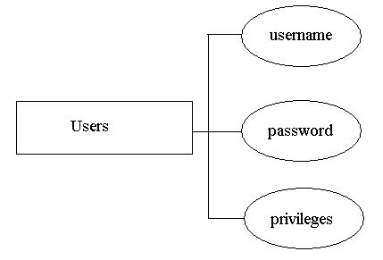
Fig 3.1: Database table structure

SERVICES
Our project delivers features and services for a text conferencing application. The main services may be identified as follows
- Membership Service: This service should be able to accomplish the task of intimating the members with the list of active members and should be able to update the details of a member joining or leaving the group.
- Multicast Service: If the membership service represents a “group” in a “group communication system”, multicast represents the “communication”. Thus multicast services responsible for delivering messages to a current membership view containing all group members.
- Message Ordering Service: Many types of GCS don’t require only reliability of packet transmission; they also require delivery of messages in a correct order. That means if two multicast m and n are sent, all members receive m before n. Since IP-multicast routing does not provide any order delivery, message ordering service is responsible to provide such functionality.

UTILITIES
  - Windows Family
  - mySQL Database
  - J2SDK 1.5
  - Java Swings & Networking APIs
  - JAAS & JCE
  - JDBC
  - Micro Processor – Pentium III Processor
  - Random Access Memory(RAM) – 256 MB
  - Secondary Storage – 40 GB Hard Disk

DATA FLOW DIAGRAMS

Accept Request
(Group Server)

Authentication Message
(User Name, Time Stamp,
Random Number,
Hash Code)
Check the validity of Hash Code
(Group Server)
Generate a Key
(Key distributor)
Negative Ack
Group Client

Positive Ack
Key
Valid

Multicast the new Key to all the
Active members of
The Group
(Multicast Server)

Figure 3.2: Group Member Authentication
  - The Group Client sends an authenticated message which includes username, timestamp, random number and hash code.
  - The Group Server accepts the authenticated message and checks for the validity of hash code.
  - If the hash code is not valid a negative acknowledgement is sent to the group client.
  - If the hash code is valid, the message is sent to the key distributor to generate a key.
  - The new key is multicasted to all the active members of the group.

Message (Encrypt (Plaintext,
Accept Request
(Group Server)
Group Key),
Authentication
Packet)

Negative Ack
Group Member
Check the
Authentication
(Group Server)

Authorized User

Multicast the message to all the
Active members of
The Group
(Multicast Server)

Figure : Group Member Sending the Message to the Group

  - Group Member sends a message which contains encrypted plaintext along with the group key and the authentication packet.
  - The Group Server accepts the request and checks the authentication packet for validation.
  - If the authentication is not valid, a negative acknowledgement is sent to the Group Member.
  - If the authentication is valid, the message is multicasted to all the Active members of the group using Multicast Server.

Logout
Message
Accept Request
(Group Server)

Check the
Authentication
(Group Server)
Group Member

Authorized

Remove Member from the Active Members List

Generate a Key
(Key distributor)

Multicast the new key to all the
Active members of
The Group
(Multicast Server)

Figure 3.4 : Group Member Sending the Logout Message
  - The Group Client sends an authenticated message which includes username, timestamp, random number and hash code.
  - The Group Server accepts the authenticated message and checks for the validity of hash code.
  - If the hash code is not valid a negative acknowledgement is sent to the group client.
  - If the hash code is valid, remove the user from the active users list and a message is sent to the key distributor to generate a key.
  - The new key is multicasted to all the active members of the group except to the user who has logged out.

CHAPTER 4

IMPLEMENTATION ISSUES

This chapter explains about the software tools used, implementation details that include code of the project, programming skills and the connectivity issues.

  - SOFTWARE TOOL USED
    - Java
A simple, object-oriented, network-savvy, interpreted, robust, secure, architecture neutral, portable, high-performance, multithreaded, dynamic language. The Java programming language and environment is designed to solve a number of problems in modern programming practice. Java started as a part of a larger project to develop advanced software for consumer electronics. These devices are small, reliable, portable, distributed, real-time embedded systems. When we started the project we intended to use C++, but encountered a number of problems. Initially these were just compiler technology problems, but as time passed more problems emerged that were best solved by changing the language.

4.1.2 MySQL
The MySQL® software delivers a very fast, multi-threaded, multi-user, and robust SQL (Structured Query Language) database server. MySQL Server is intended for mission-critical, heavy-load production systems as well as for embedding into mass-deployed software. MySQL is a registered trademark of MySQL AB.

  - IMPLEMENTATION DETAILS
    - CODING
//Server Side
public class ProtectedServer extends Thread {
public boolean authenticate(String username,String password,DataInputStream in)
throws IOException, NoSuchAlgorithmException {
long t1 = in.readLong();
double q1 = in.readDouble();
int length = in.readInt();
byte[] protected1 = new byte[length];
in.readFully(protected1,0,length);
byte[] local = Protection.makeDigest(username, password, t1, q1);
return (MessageDigest.isEqual(protected1, local));
}

protected String lookupPassword(String user) {
try
{
Class.forName("com.mysql.jdbc.Driver");
}
catch(ClassNotFoundException ce)
{
ta.append(ce+"\n");
}
try
{
url="jdbc:mysql://localhost:3306/test";
con=DriverManager.getConnection(url,"root","root");
stmt=con.createStatement();
ResultSet rs=stmt.executeQuery("select password from users where users_name='"+user+"'");
if(rs.next())
passwd=rs.getString(1);
}
catch(SQLException ce){
ta.append("Error:"+ce);
}
if(passwd!=null)
return passwd;
return(""+"null");
}

public void run() {
try{
ob = new MulticastServerThread(groupId,groupPort);
SecretKey longtimeKey = null;
SecretKey key = null;
SecretKey currentKey = null;
int noUsers=0;
s = new ServerSocket(serverPort);
for(;;){
ta.append("Waiting for Members:\n");
Socket client = s.accept();
ta.append("Spawning............\n");
DataInputStream in = new DataInputStream(client.getInputStream());
int opt=in.readInt();
String username = in.readUTF();
String password = lookupPassword(username);
if(opt == 1) {
ta.append("New User tried to contact:\n");
if(authenticate(username,password,in)){
if(!(addUser(username,password))){
ta.append("Client failed to log in.\n");
try{
DataOutputStream out = new DataOutputStream(client.getOutputStream());
out.writeInt(0);
}
catch(Exception e) {}
}
else{
noUsers++;
ta.append("Client logged in.\n");
DataOutputStream out=new DataOutputStream(client.getOutputStream());
try{
currentKey = makeKey();
if(noUsers>1) {
//Wrap the current using the key
byte[] buff = makeWrap(currentKey,key);
//Create a ByteArrayOutputStream to send all the data into it
ByteArrayOutputStream bout = new ByteArrayOutputStream();
DataOutputStream dout = new DataOutputStream(bout);
//Write the flag value 1 to differntiate between the mesg and key packets
dout.writeInt(1);
//Write the length of the key buffer
dout.writeInt(buff.length);
//Write the wrapped key
dout.write(buff,0,buff.length);
dout.flush();
ob.multicast(bout.toByteArray());
dout.close();
}
key = currentKey;
SecretKey longtermKey = makeDESKey(password.getBytes(),0);
byte[] buff = makeWrap(currentKey,longtermKey);
out.writeInt(1);
out.write(buff, 0,buff.length);

//Multicasting the Current Users List
StringBuffer userslist = getUsers();
String list = userslist.toString();
users_list.setText(list);
byte[] buffer = list.getBytes();
Cipher cipher =Cipher.getInstance("DES");
cipher.init(Cipher.ENCRYPT_MODE, key);
ByteArrayOutputStream cbout = new ByteArrayOutputStream();
CipherOutputStream cout = new CipherOutputStream(cbout,cipher);
cout.write(buffer,0,buffer.length);
cout.flush();
cout.close();
byte[] encryptMesg = cbout.toByteArray();
//Send the users list to the new Member
out.writeInt(encryptMesg.length);
out.write(encryptMesg,0,encryptMesg.length);

//Write the message
//Create ByteArrayOutputStream to send all the data into it
ByteArrayOutputStream bout = new ByteArrayOutputStream();
DataOutputStream dout = new DataOutputStream(bout);
dout.writeInt(3);
dout.writeInt(encryptMesg.length);
dout.write(encryptMesg,0,encryptMesg.length);
ob.multicast(bout.toByteArray());
}
catch(Exception e) {
ta.append(e+"\n");
}
}
}
if(opt == 0) {
try {
if(authenticate(username,password,in)){
ta.append("Multicasting the Message\n");
int encryptmsgLen = in.readInt();
byte[] mesg = new byte[encryptmsgLen];
in.readFully(mesg,0,encryptmsgLen);
//Write the message
//Create a ByteArrayOutputStream to send all the data into it
ByteArrayOutputStream bout = new ByteArrayOutputStream();
DataOutputStream dout = new DataOutputStream(bout);
dout.writeInt(2);
dout.writeInt(encryptmsgLen);
dout.write(mesg,0,encryptmsgLen);
ob.multicast(bout.toByteArray());
}
}
catch(Exception e) {}

}
if(opt == 2) {
try {
if(authenticate(username,password,in)){
ta.append("ClientLoggedout\n");
noUsers--;
removeUser(username);
//Multicasting the Current Users List
StringBuffer userslist = getUsers();
String list = userslist.toString();
users_list.setText(list);
byte[] buffer = list.getBytes();
Cipher cipher =Cipher.getInstance("DES");
cipher.init(Cipher.ENCRYPT_MODE, key);
ByteArrayOutputStream cbout = new ByteArrayOutputStream();
CipherOutputStream cout = new CipherOutputStream(cbout,cipher);
cout.write(buffer,0,buffer.length);
byte[ ] encryptMesg = cbout.toByteArray();
//Write the message
//Create a ByteArrayOutputStream to send all the data into it
ByteArrayOutputStream bout = new ByteArrayOutputStream();
DataOutputStream dout = new DataOutputStream(bout);
dout.writeInt(3);
dout.writeInt(encryptMesg.length);
dout.write(encryptMesg,0,encryptMesg.length);
ob.multicast(bout.toByteArray());
currentKey = makeKey();
if(noUsers>1){
//Wrap the current using the key
byte[] buff = makeWrap(currentKey,key);
//Create a ByteArrayOutputStream to send all the data into it
bout = new ByteArrayOutputStream();
dout = new DataOutputStream(bout);
//Write the flag value 1 to differntiate between the mesg and key packets
dout.writeInt(1);
//Write the length of the key buffer
dout.writeInt(buff.length);
//Write the wrapped key
dout.write(buff,0,buff.length);
dout.flush();
ob.multicast(bout.toByteArray());
dout.close();
key = currentKey;
}
}
}catch(Exception e){}
}
}
public void stopServer() {
try{
//Write the message
//Create a ByteArrayOutputStream to send all the data into it
ByteArrayOutputStream bout = new ByteArrayOutputStream();
DataOutputStream dout = new DataOutputStream(bout);
dout.writeInt(4);
dout.flush();
dout.close();
ob.multicast(bout.toByteArray());
s.close();
}
catch(Exception e){
ta.append(e+"\n");
}
}
public byte[] makeByteFromDESKey(SecretKey ki)
throws NoSuchAlgorithmException,InvalidKeySpecException {
SecretKeyFactory desFactory = SecretKeyFactory.getInstance("DES");
DESKeySpec spec = (DESKeySpec) desFactory.getKeySpec(ki,
DESKeySpec.class);
return spec.getKey();
}
public SecretKey makeDESKey(byte[] input, int offset)
throws NoSuchAlgorithmException, InvalidKeyException, InvalidKeySpecException {
SecretKeyFactory desFactory = SecretKeyFactory.getInstance("DES");
KeySpec spec = new DESKeySpec(input, offset);
return desFactory.generateSecret(spec);
}
public SecretKey makeKey()
throws NoSuchAlgorithmException {
KeyGenerator keyGen = KeyGenerator.getInstance("DES");
keyGen.init(new SecureRandom());
return keyGen.generateKey();
}
public byte[] makeEncryption(byte[] buffer,javax.crypto.SecretKey key)
throws NoSuchAlgorithmException, NoSuchPaddingException , InvalidKeyException, IllegalBlockSizeException, BadPaddingException{
Cipher cipher =Cipher.getInstance("DES");
cipher.init(Cipher.ENCRYPT_MODE, key);
cipher.update(buffer);
return cipher.doFinal();
}
public byte[] makeWrap(SecretKey cur_key,SecretKey key)
throws NoSuchAlgorithmException, NoSuchPaddingException , InvalidKeyException, IllegalBlockSizeException, BadPaddingException{
Cipher cipher =Cipher.getInstance("DES");
cipher.init(Cipher.WRAP_MODE, key);
return cipher.wrap(cur_key);
}
}

//Protection.java

public class Protection {
public static byte[] makeDigest(String user, String password,
long t1, double q1) throws NoSuchAlgorithmException {
MessageDigest md = MessageDigest.getInstance("SHA");
md.update(user.getBytes());
md.update(password.getBytes());
md.update(makeBytes(t1, q1));
return md.digest();
}
public static byte[] makeBytes(long t, double q) {
try {
ByteArrayOutputStream byteOut = new ByteArrayOutputStream();
DataOutputStream dataOut = new DataOutputStream(byteOut);
dataOut.writeLong(t);
dataOut.writeDouble(q);
return byteOut.toByteArray();
}
catch (IOException e) {
return new byte[0];
}
}
}

//Client side

public class GroupClient extends JFrame implements ActionListener
{
public GroupClient()
{
super("Client Authentication");
public void sendAuthentication(String user, String password,
OutputStream outStream) throws IOException, NoSuchAlgorithmException {
DataOutputStream out = new DataOutputStream(outStream);
long t1 = (new Date()).getTime();
double q1 = Math.random();
byte[] protected1 = Protection.makeDigest(user, password, t1, q1);

out.writeInt(1);
out.writeUTF(user);
out.writeLong(t1);
out.writeDouble(q1);
out.writeInt(protected1.length);
out.write(protected1);
out.flush();
}
public void actionPerformed(ActionEvent ae){
if(ae.getSource()==ok){
try{
Socket s = new Socket("localhost",7999);
char[] pwd=password.getPassword();
String psw = new String(pwd);
sendAuthentication(username.getText(),psw,s.getOutputStream());
DataInputStream in = new DataInputStream(s.getInputStream());
int val = in.readInt();
if(val==1){
setLocation(250,150);
byte[] b = new byte[16];
in.readFully(b,0,16);
SecretKeyFactory desFactory = SecretKeyFactory.getInstance("DES");
KeySpec spec = new DESKeySpec(psw.getBytes(),0 );
longtermKey = desFactory.generateSecret(spec);
Cipher cipher =Cipher.getInstance("DES");
cipher.init(Cipher.UNWRAP_MODE,longtermKey);
key = cipher.unwrap(b,"DES",Cipher.SECRET_KEY);

StringBuffer users = new StringBuffer();
int encrylength = in.readInt();
byte[] buff = new byte[encrylength];
in.read(buff,0,encrylength);
Cipher decipher = Cipher.getInstance("DES");
decipher.init(Cipher.DECRYPT_MODE,key);
ByteArrayInputStream dbin = new ByteArrayInputStream(buff);
CipherInputStream cin = new CipherInputStream(dbin, decipher);
byte[] decrymesg = new byte[encrylength];
int no = cin.read(decrymesg);

while(no!=-1) {
users.append(new String(decrymesg,0,no));
no = cin.read(decrymesg);
}
GroupMember ob = new GroupMember(username.getText(),psw,key,users.toString(),groupId.getText(),Integer.parseI nt(groupPort.getText()),serverId.getText(),Integer.parseInt(serverPort.getText()));
ob.setVisible(true);
ob.setLocation(300,150);
setVisible(false);
}
else{
setLocation(250,150); JOptionPane.showMessageDialog(this,"Invalid UserName or Password or Member has already logged","ErrorMessage",JOptionPane.ERROR_MESSAGE);
}
in.close();
s.close();
}
catch(Exception ce){
setLocation(250,150);
JOptionPane.showMessageDialog(this,""+ce,"ErrorMessage",JOptionPane.ERROR_MESSAGE);
}
username.setText("");
password.setText("");
}
if(ae.getSource()==cancel){
System.exit(0);
}
}
public GroupMember(String username, String password,Key key,String users,String groupId,int groupPort,String serverId,int serverPort)
{
super("Group Member");
public void run(){
int i=1;
try{
ms = new MulticastSocket(groupPort);
InetAddress ia= InetAddress.getByName(groupId);
ms.joinGroup(ia);
byte[] buffer = new byte[512];
for(;;){
DatagramPacket dp= new DatagramPacket(buffer, buffer.length);
ms.receive(dp);
ByteArrayInputStream bin = new ByteArrayInputStream(dp.getData());
DataInputStream din = new DataInputStream(bin);
int flag = din.readInt();
if(flag == 1) {
int length = din.readInt();
byte[] buff = new byte[length];
din.readFully(buff,0,length);
Cipher cipher=Cipher.getInstance("DES");
cipher.init(Cipher.UNWRAP_MODE,key);
currentKey = cipher.unwrap(buff,"DES",Cipher.SECRET_KEY);
key = currentKey;
}
if(flag == 2) {
int encrylength = din.readInt();
byte[] buff = new byte[encrylength];
din.read(buff);
Cipher decipher = Cipher.getInstance("DES");
decipher.init(Cipher.DECRYPT_MODE,key);
ByteArrayInputStream dbin = new ByteArrayInputStream(buff);
CipherInputStream cin = new CipherInputStream(dbin, decipher);
byte[] decrymesg = new byte[encrylength];
int no = cin.read(decrymesg);
while(no!=-1) {
ta.append(new String(decrymesg,0,no));
no = cin.read(decrymesg);
}
ta.append("\n");
}
if(flag == 3){
users_list.setText("");
int encrylength = din.readInt();
byte[] buff = new byte[encrylength];
din.read(buff);
Cipher decipher = Cipher.getInstance("DES");
decipher.init(Cipher.DECRYPT_MODE,key);
ByteArrayInputStream dbin = new ByteArrayInputStream(buff);
CipherInputStream cin = new CipherInputStream(dbin, decipher);
byte[] decrymesg = new byte[encrylength];
int no = cin.read(decrymesg);
while(no!=-1) {
users_list.append(new String(decrymesg,0,no));
no = cin.read(decrymesg);
}
}
}
}
catch(Exception e) {
ta.append("\nError:"+e);
}
}

public void actionPerformed(ActionEvent ae){
if( ae.getSource()==send)
{
if(ta1!=null){
try{
Socket s = new Socket(serverId,serverPort);
DataOutputStream out = new DataOutputStream( s.getOutputStream());
long t1 = (new java.util.Date()).getTime();
double q1 = Math.random();
byte[] protected1 = Protection.makeDigest(username, password, t1, q1);
String msg = username+" :"+ta1.getText();
byte[] buffer = msg.getBytes();
Cipher cipher =Cipher.getInstance("DES");
cipher.init(Cipher.ENCRYPT_MODE, key);
ByteArrayOutputStream cbout = new ByteArrayOutputStream();
CipherOutputStream cout = new CipherOutputStream(cbout,cipher);
cout.write(buffer,0,buffer.length);
cout.flush();
cout.close();
byte[] encryptMesg = cbout.toByteArray();
out.writeInt(0);
out.writeUTF(username);
out.writeLong(t1);
out.writeDouble(q1);
out.writeInt(protected1.length);
out.write(protected1);
out.writeInt(encryptMesg.length);
out.write(encryptMesg);
out.flush();
out.close();
s.close();
ta1.setText("");
}catch(Exception ce){
setLocation(250,150);
JOptionPane.showMessageDialog(this,""+ce,"ErrorMessage",JOptionPane.ERROR_MESSAGE);
}
}
}

if( ae.getSource()==logout)
{
try{
Socket s = new Socket(serverId,serverPort);
DataOutputStream out = new DataOutputStream( s.getOutputStream());
long t1 = (new java.util.Date()).getTime();
double q1 = Math.random();
byte[] protected1 = Protection.makeDigest(username, password, t1, q1);
out.writeInt(2);
out.writeUTF(username);
out.writeLong(t1);
out.writeDouble(q1);
out.writeInt(protected1.length);
out.write(protected1);
out.flush();
out.close();
s.close();
System.exit(0);
}catch(Exception ce){
setLocation(250,150);
}
}
}

    - PROGRAMMING TECHNIQUES
How to start:
- Start the server by clicking the Start Server button.
- Run the Client application
- Client enters his username and password.
- The client will be authenticated and will be added to the active user list by the server.
- Thus the client program is started.

Registration of Users and Servers:
All members participating in the communication need to get registered by supplying their user name and password to the server. Then if the client is a valid group member then the server sends the newly generated symmetric key to all the clients involved in communication.

Server Administration:
Every user needs to be registered by the Server Administrator in order to get his/her security credentials (username/password). After the first login, the User needs to request his/her key (Symmetric Key) from the server in order to be able to perform remaining functions. Every User needs to establish a secure session in order to execute functions on a server. Therefore, both (Server and Client) exchange and verify their keys, perform strong authentication and the server checks its local database (Hash table) to verify whether the user is a valid member or not. If no corresponding entry is found, the session is cancelled; otherwise, a secure session is established.

Group Management:
This section describes group management functions performed by a Group Communication Server (GCS).
The Processes of initial steps including login and establishing a secure channel with the server are equivalent to that of a Server Administrator explained above.

Creation of a Key and a Group:
Once the Member has successfully connected to a server, he/she can create new groups. The Member first needs to create a group Key (symmetric key) containing the group’s security settings and members.
This contains the following information:
- User ID/Pass word
- Authorizations(owner and key Servers)
- Access Control( Which user may join the group)
- Security Mechanisms (algorithms, protocols, rekey information, etc.)

Group Maintenance:
Group Communication Server (GCS) performs most of the necessary group maintenance functions. These functions include group access control and key management functions, as well as administrative functions to maintain consistency between all members.

Group Participation:
Once a group has been created on a Group Communication Server (GCS), other users can participate in this group using GCS client interface. Therefore, a session with individual server needs to be established before group functions can be used.
After receiving information about all clients running on a server, the User can request to join a group by sending a “Request to Join” message. When the server receives a group- joining request, it verifies first the complete message, including user’s name and password and then checks the key if he/she is authorized to become a member or not.
Assuming a User has successfully joined a group and shares a key with the server, he/she is able to obtain the group key processing the follow-up “Rekey” message.

Group Rekeying:
To ensure forward and backward secrecy, the group key needs to be updated and distributed whenever a member joins or leaves the group. Thus, a “Rekey” message is sent to all members.
GCS Applications:
Once Users have joined a group and obtained the group key, they can use this key to securely exchange all kind of data with other Member’s. Our current implementation supports exchange of secure messages in order to demonstrate secure group communication. These messages are encrypted with public key crypto system.

Group Closure:
Once a group has been created on a Group Communication System (GCS), other Users can participate in this group using GCS Client interface. Therefore, a session with individual server needs to be established before group functions can be used.

Group Creation:
Once a group has been created on a Group Communication System (GCS), other Users can participate in this group using GCS client interface. Therefore, a session with individual server needs to be established before group functions can be used.
After receiving information about all clients running on a server, the User can request to join a group by sending a “Request to Join” message. When the server receives a group-joining request, it verifies first the complete message, including user’s name and password and then checks the key if he/she is authorized to become a member or not.
Almost equivalent to opening a group is closing a group. When the Member decides that he/she is not interested in participating in the group activity, he/she can get deleted from the group. Therefore, a Member sends a removal request to the server indicating that he/she has to be getting deleted from the Group. The server verifies, whether the request originates from the Member of the group or not. Assuming successful verification, the server deletes the member from the group, and informs all the current members of the group, and informs all current Members about the removal.
Group Membership:
This is used by Users to join groups and use the group key for secure group applications, such as secure message exchange.
When a user wants to join a group, he/she sends a “Request to join” message to the server. The server then update the member’s list, performs access control to the group, based on the username and password, and responds with a “Key Download” message. Group Member’s are now able to send and receive secure group information exchanged among all Group Member’s. As already mentioned, this group key can be used to exchange every other type of electronic data, such as electronic documents. Finally, messages exchanged when Group Member’s are leaving a group. The Group member informs the server that he/she wants to leave the group. To ensure forward secrecy, the server generates a new random symmetric key, which is published to the entire group in such a way that all members except the one who is leaving are able to extract the new group key. The server then sends a message to update new membership view.

    - CONNECTIVITY ISSUES
INSTALLATION
- There must be at least two machines with Windows XP Professional or Windows 98 installed.
- Arbitrarily select one machine as Server and one as a Client.
- Install the jdk1.5.0_12 in both Client and Server. Make available the Swings.jar file in the directory where the jdk is stored.
- Install the MySQL Server 5.0 in the Server machine. Make available the MySQL.zip file in the directory where the MySQL is stored.
- Now, Store the Client class files in the client machine and the server class files in the server machine.

CONFIGURATION
- Change the IP Address of the server machine in the client side. Just change the IP Address to the current server IP address.
- Now the program is ready to run.

    - ARCHITECTURE DIAGRAM

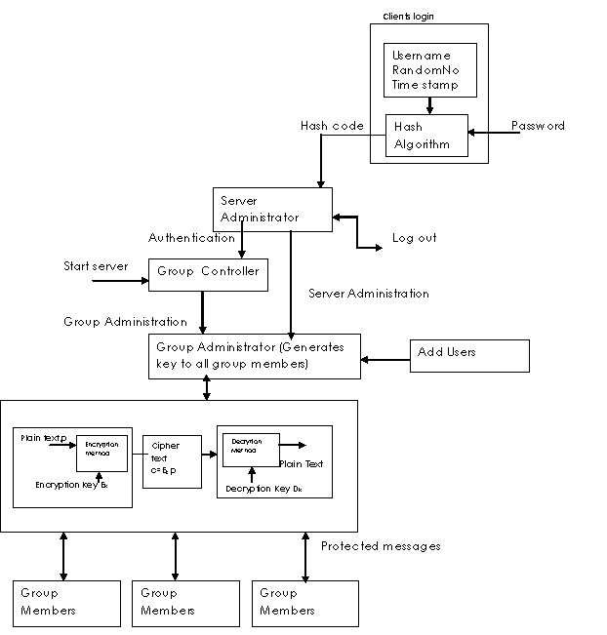
Fig 4.1: Architecture of SGCS

CHAPTER-5

TESTING

This chapter describes about the test conducted to verify the proper working of the project and also gives the results obtained from these tests.

  - SCOPE
Software testing may be viewed as an important part of the software quality assurance (SQA) process. In SQA, software process specialists and auditors take a broader view on software and its development. They examine and change the software engineering process itself to reduce the amount of faults that end up in defect rate. What constitutes an acceptable defect rate depends on the nature of the software. An arcade video game designed to simulate flying an airplane would presumably have a much higher tolerance for defects than software used to control an actual airliner. Although there are close links with SQA testing departments often exist independently, and there may be no SQA areas in some companies.

The software faults occur through the following process. A programmer makes an error (mistake), which results in a defect (fault, bug) in the software source code. If this defect is executed, in certain situations the system will produce wrong results, causing a failure. Not all defects will necessarily result in failures. For example, defects in a dead code will never result in failures. A defect can turn into a failure when the environment is changed. Examples of these changes in environment include the software being run on a new hardware platform, alterations in source data or interacting with different software.
A problem with software testing is that testing all combinations of inputs and preconditions is not feasible when testing anything other than a simple product. This means that the number of defects in a software product can be very large and defects that occur infrequently are difficult to find in testing. More significantly, parafunctional dimensions of quality--for example, usability, scalability, performance, compatibility, reliability--can be highly subjective; something that constitutes sufficient value to one person may be intolerable to another.
There are many approaches to software testing. Reviews, walkthroughs or inspections are considered as static testing, whereas actually running the program with a given set of test cases in a given development stage is referred to as dynamic testing.
Software testing is used in association with verification and validation.
- Verification: Have we built the software right (i.e., does it match the specification)?
- Validation: Have we built the right software (i.e., is this what the customer wants)?
Software testing can be done by software testers. Until the 1950s the term software tester was used generally, but later it was also seen as a separate profession. Regarding the periods and the different goals in software testing there have been established different roles: test lead/manager, tester, test designer, test automater/automation developer, and test administrator.
  - FUNCTIONAL TESTING
Application functional testing is the most widely accepted testing practice in software development organizations today, and hundreds of millions of dollars have been spent on automated tools to support the practice. Yet, organizations still struggle to achieve software quality and suffer inconsistent, inefficient, and often inaccurate application of the practice.
Software development organizations with an effective functional testing practice have a fast and objective way to determine whether each functional requirement is actually implemented in the code. With functional testing, the team translates functional requirements into executable test cases that confirm how well the code satisfies the requirements at any given time. It provides unprecedented objective insight into requirement status and prevents the missing or incorrect functionality implementations that can lead to countless rewrites (and then budget overruns and missed deadlines), user dissatisfaction, and project failure.
In our project we developed several use cases based on the scenarios that the user might have to face. The effectiveness of theses use cases was further justified when we were able to translate it into a test plan. The test plan used is developed and implemented to build a suite of executable tests that frame and verify the functionality requirements, providing a fast and objective way to assess the status of expected functionality. These tests when executed regularly ensure that code modifications do not unintentionally change previously verified functionality.
An effective functional testing practice involves the definition of guidelines for using functional testing technologies effectively, and then the implementation and integration of those guidelines (along with supporting technologies and configurations) into your software development lifecycle to ensure that your teams apply the policy consistently and regularly. It also requires a means to monitor and measure the policy's application, as well as report the data it is tracking.
  - BLACK BOX TESTING
Black box testing takes an external perspective of the test object to derive test cases. These tests can be functional or non-functional, though usually functional. The test designer selects valid and invalid input and determines the correct output. There is no knowledge of the test object's internal structure.
This method of test design is applicable to all levels of software testing: unit, integration, functional testing, system and acceptance. The higher the level, and hence the bigger and more complex the box, the more one is forced to use black box testing to simplify. While this method can uncover unimplemented parts of the specification, one cannot be sure that all existent paths are tested.

  - ALPHA TESTING
Alpha testing is the absolute primary actual run testing of software; it's a very rough build. From what a developer learns in alpha testing they make changes to their product and generally conduct a more open beta test that is a far better product overall but still a far cry from the final build. From beta they make changes towards the final product. Alpha testing is generally extremely exclusive whereas beta testing is quite regularly open to the public provided that they sign up and such.It is simulated or actual operational testing by potential users/customers or an independent test team at the developers' site. Alpha testing is often employed for off-the-shelf software as a form of internal acceptance testing, before the software goes to beta testing.

Our projects alpha run faced a series of impediments. Some of which include when
  - When the server was already started and running in some port and the user tried to start the server again, there was no intimation to the user that the server was already running.
We resolved it by making the server to throw an exception on the console: “Server is already running in some port” whenever the user tries to run the server when the server is already running.
  - Initially when the client had already logged in the group and tried to log in with the same username and password the server would accept the client to log in and spawn a new thread again.
We managed to resolve this by making the server to throw an exception: “User is already logged in” whenever he tries to log in with the same username and password again.

  - BETA TESTING
It comes after alpha testing. Versions of the software, known as beta versions, are released to a limited audience outside of the programming team. The software is released to groups of people so that further testing can ensure the product has few faults or bugs. Sometimes, beta versions are made available to the open public to increase the feedback field to a maximal number of future users.

The Beta version of our application was released keeping in mind the minimalistic features that it would support. The test so far has yielded positive outcomes with no complains coming from any of the participants in the test.

  - TEST CASES

Test case 1
The User Result Comment
Interface test

Open Group Enter Group name, Group ID, Group Port, Succeeded
Screen Server ID, Server Port
Opens Group Controller Screen.

Group Controller Press Start Server Succeeded
Screen

Client Authentication Enter the User name, Password, Group ID,
Screen Group Port, Server ID, Server Port Failed

Enter the User name, Password, Group ID, Succeeded
Group Port, Server ID, Server Port

Group Member Displays Users List.
Screen Messages can be Sent, Cleared, and Logged out Succeeded

Test case 2
The User Result Comment
Interface test

Open Group Enter Group name, Group ID, Group Port, Succeeded
Screen Server ID, Server Port
Opens Group Controller Screen.

Group Controller Press Start Server Succeeded
Screen

Client Authentication Enter the User name, Password, Group ID, User not a
Screen Group Port, Server ID, and Server Port member
Failed.

Enter the User name, Password, Group ID, Succeeded
Group Port, Server ID, Server Port

Group Member Displays Users List.
Screen Messages can be Sent, Cleared, and Logged out Succeeded

Creation of users Open Creation of User Screen
Enter User name, Password and privileges Succeeded

Test case 3
The User Result Comment
Interface test

Open Group Enter Group name, Group ID, Group Port, Group name
Screen Server ID, Server Port not valid
Opens Group Controller Screen.

Enter Group name, Group ID, Group Port, Succeeded
Server ID, Server Port
Opens Group Controller Screen.

Group Controller Press Start Server Succeeded
Screen

Client Authentication Enter the User name, Password, Group ID,
Screen Group Port, Server ID, Server Port Failed

Enter the User name, Password, Group ID, Succeeded
Group Port, Server ID, Server Port

Group Member Displays Users List.
Screen Messages can be Sent, Cleared, and Logged out Succeeded

CHAPTER-6

RESULTS

This chapter explains about the output obtained in the project. It provides the snapshot of the output pages obtained.

  - SNAP SHOTS OF PROJECT
Group Administrator:

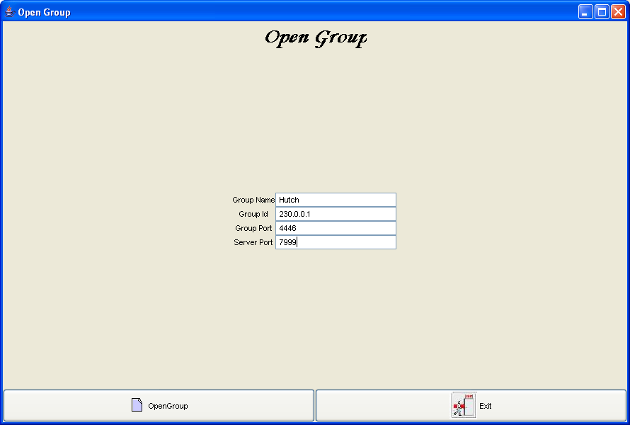
Fig 6.1: Opening of a group
This is the form to open a group. Here, a group administrator has to enter a specific group name and group id.

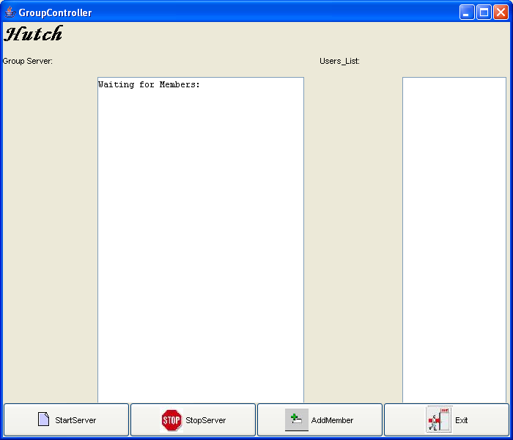
Fig 6.2 : Group Controller form
Group Controller is an authority to create group on a specific SGCA server, to start and stop the server as well as adding new members to the group.

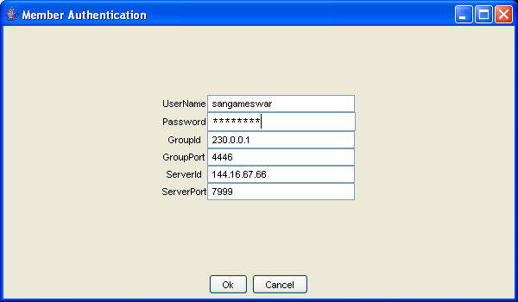
Fig 6.3 : Member Authentication
This is the login form for a user where he has to authenticate his/her credentials.

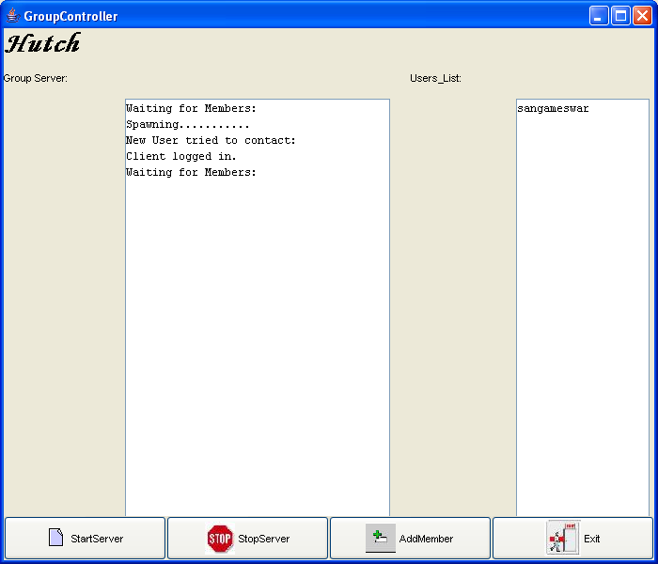
Fig 6.4: Server Output
This form gives the outcome when one of the users has been added to the group.

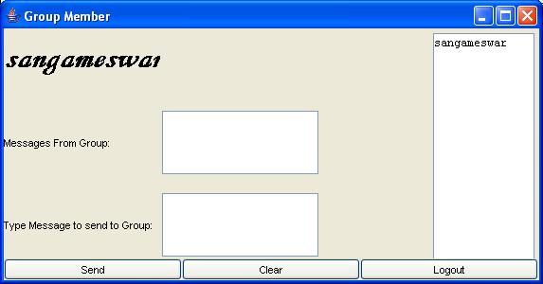
Fig 6.5: Member Logged in
This form is the outcome of a successful login of a member to a group. This form facilitates the sending and receiving of messages.

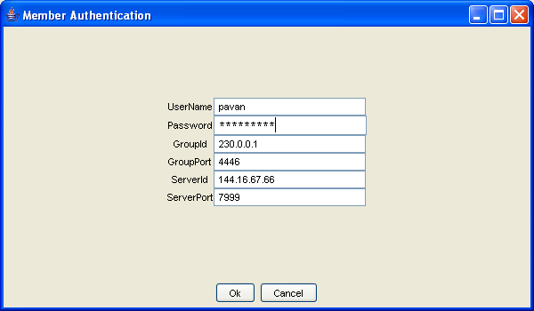
Fig 6.6 : Member Authentication
This is the login form for a second user where he has to authenticate his/her credentials.

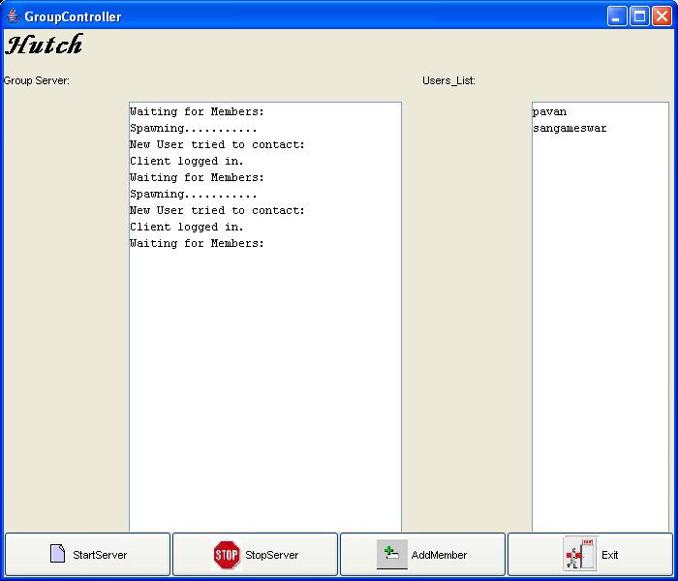
Fig 6.7: Server Output
This form gives the outcome when both the users have been successfully added to the group.

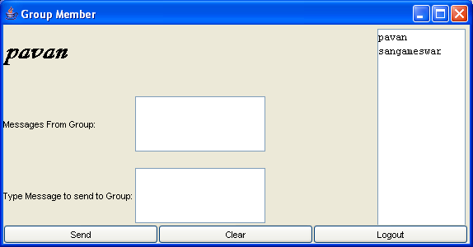
Fig 6.8: Member Logged in
This form is the outcome of a successful login of the second member to a group. This form facilitates the sending and receiving of messages.

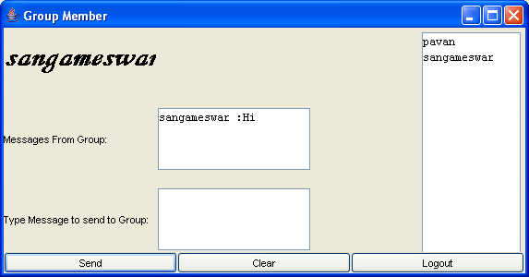
Fig 6.9: Members exchanging messages

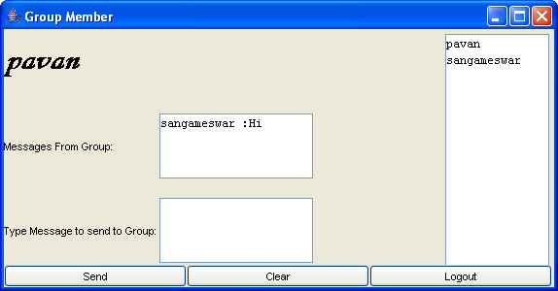
Fig 6.10: Members exchanging messages

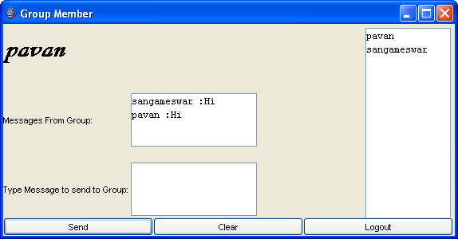
Fig 6.11: Members exchanging messages

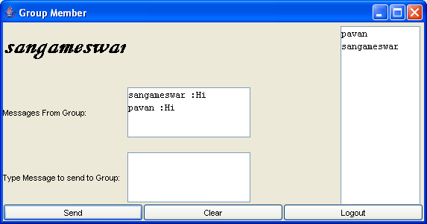
Fig 6.12: Members exchanging messages
The above forms (Fig 6.9 to 6.12) shows the members exchanging messages.

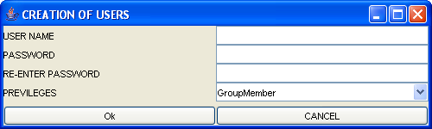
Fig 6.13: Form to create Users

This form allows the Group Administrator to add new members to the database.

CHAPTER 7
CONCLUSION

  - CONCLUSION
This project is an implementation based on providing basics of secure group communication, the definition of group communication, need for its security and functions implemented to secure group communication.

Also the project focuses on the architecture of secure group communication system and its roles, the Design issues and the group management and also:

- Registration of all participating entities,
- Key agreement in order to provide security services,
- Exchange of secure messages to support security applications, and
- Access control to groups as well as common group data.

Finally the project discusses the implementation details, restrictions and assumptions and limitations.

In spite of the above-mentioned limitations arising due to the centralized system it is the easiest way to implement the above. Analysis has proved that protocols based on hierarchical sub grouping are relatively harder to implement and raise other issues, such as interfering with the data path or imposing security hazards on the group. Distributed key management, by design is simply not scalable. Additionally, the best solution for a particular application may not be suited for another.

7.2 Future Work
To overcome the problem arising in the implementation, there are many approaches under research. There are two ways in which there can be some success in overcoming that limitation namely

Decentralized architectures: The management of a large group is divided among subgroup managers, trying to minimize the problem of concentrating the working at a single point.

Distributed key management protocols: There is no explicit KDC, and the members themselves do the key generation. All the members can perform access control and the generation of the key can be either contributory, meaning that all members contribute some information to generate the group key, or done by one of the members.

BIBLOGRAPHY

Books

[1] Cryptography and Network Security – William Stallings, Prentice Hall India

[2] HandBook of Applied Cryptography – Alfred J. Menezes, Paul C. van Oorschot, Scott A. Vanstone.

[3] Java Security – Scott Oaks-Second Edition, Oreilly Publication

[4] Java Cryptography – Jonathan B. Knudsen, Oreilly Publication

[5] Java Network Programming – Elliotte Rusty, Harlord–Second Edition, Oreilly Publication

[6] Advanced Java Networking – Prasanth Sridharan , Prentice Hall

[7] The Complete Reference Java 2 – Patrick Naughton and Herbert Schildt – Fifth Edition, Tata McGraw–Hill Edition

[8] Efficient Key Agreement for Ad-hoc Networks – Maarit Hietalahti, Master’s Thesis

[9] Authenticated Group Key Agreement and Friends – Giuseppe Ateniese, Michael Steiner, Gene Tsudik

Internet Sites

- http://java.sun.com
- http://www.cnds.jhu.edu/research/group

